I looked into my old notes and page 2 save 6 was week 2 or 3 of Tom’s route, so I’ll start there

Oh, so that’s where build B ends. And it’s still behaving like build B, kicking me back to the main menu.

I went back to Tom’s save and Cv3 works. I’m on the break after the attack.

Saved on the Sue dialogue option, choosing one at a time until they’re all tested

Confirmed that this Sue event has MC mention Edward on the correct route, so that’s a good sign

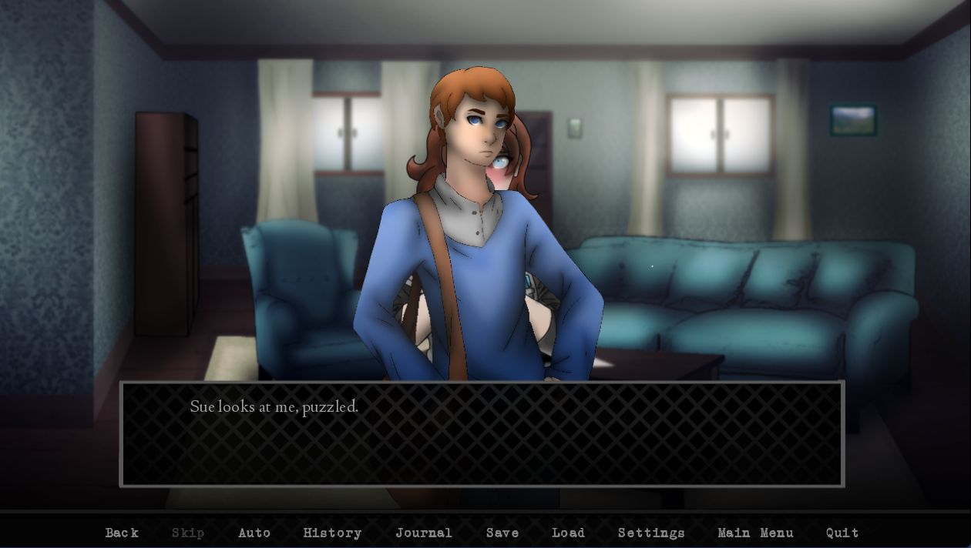

That’s not Falco- I mean, Sue. It’s supposed to be just me and her

Saving the last screen I can get to page 2 save 6

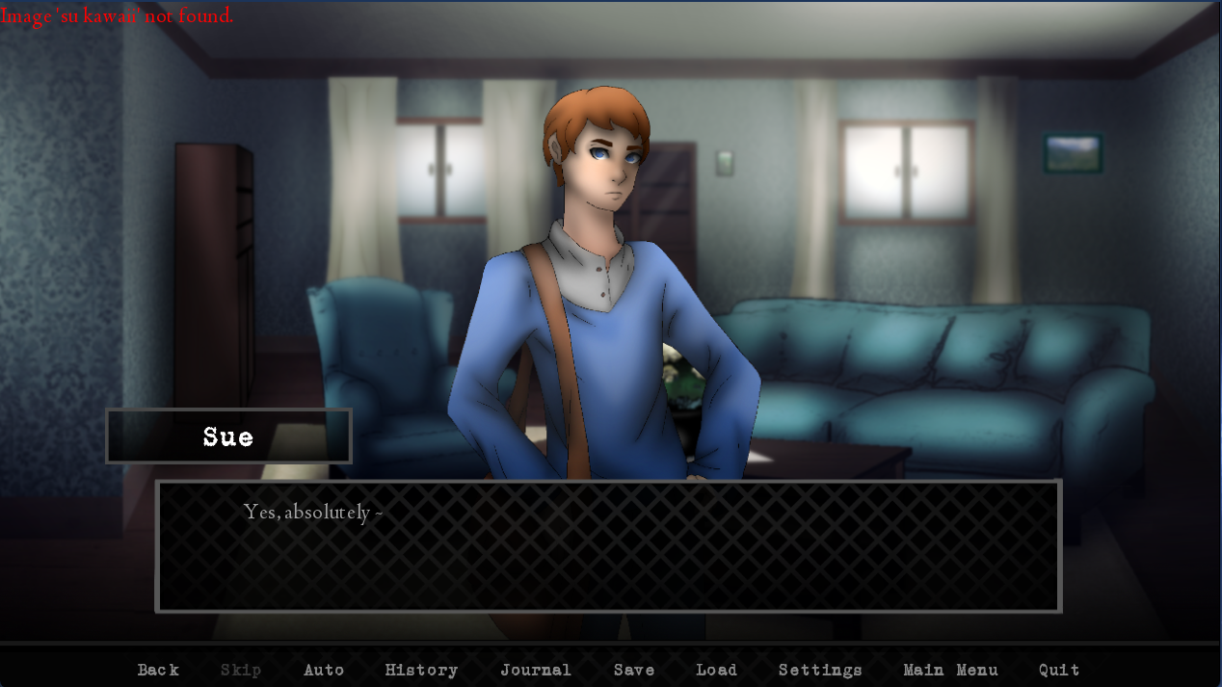

Sue melts away at the mention of coffee

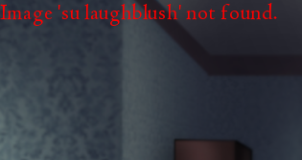 This one’s missing too

That’s everything from just Sue I think. Onto the second option, her and Julia

Julia’s acknowledged but hasn’t shown up in sprite form yet

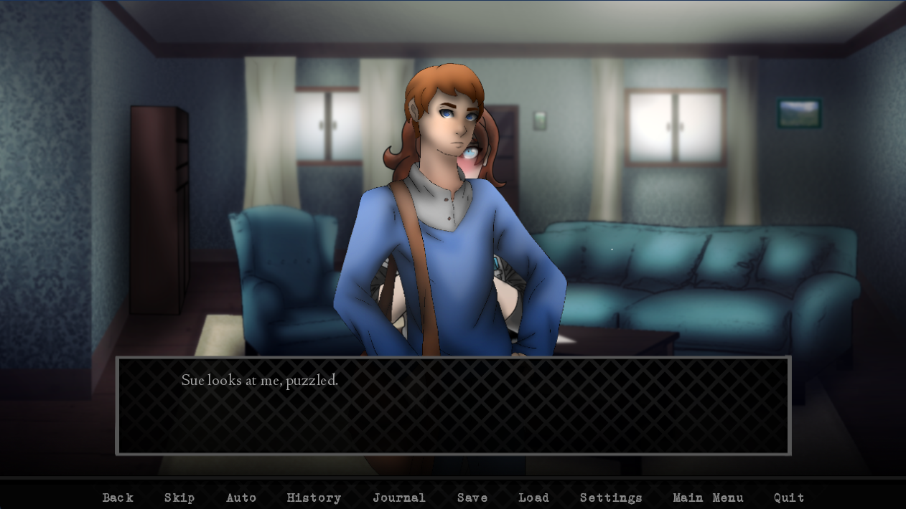

Same thing on this one

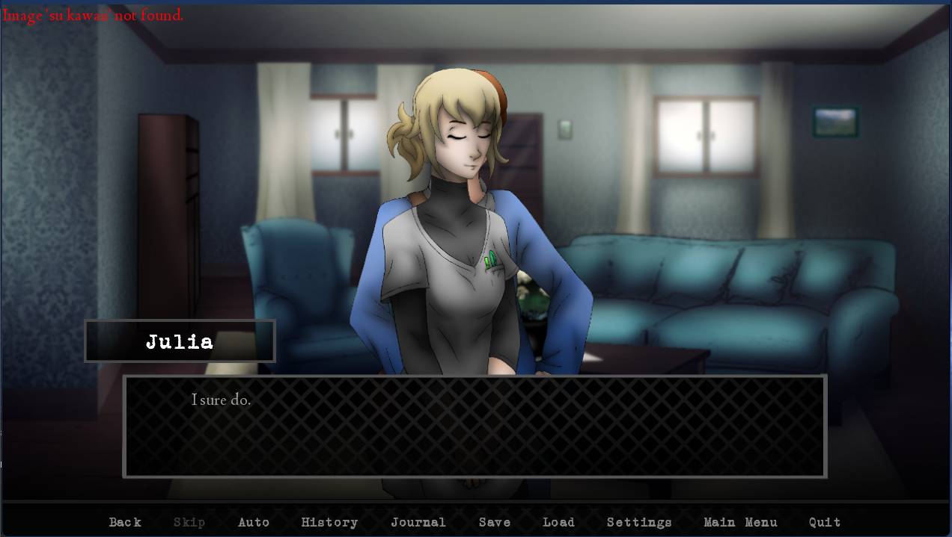

Finally. But when getting help with coffee I can only invite Sue. “Julia grabs her coffee” is the first time Julia shows up on the right side of the screen.

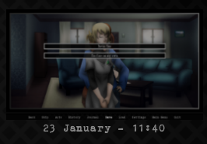There might be something going on that corrupted this gamesave or thumbnail. I don’t remember saving on this dialogue option. I don’t think I would have since it’s the same options as before when I was alone with Sue. Nevermind, I confirmed it was a gamesave I made.

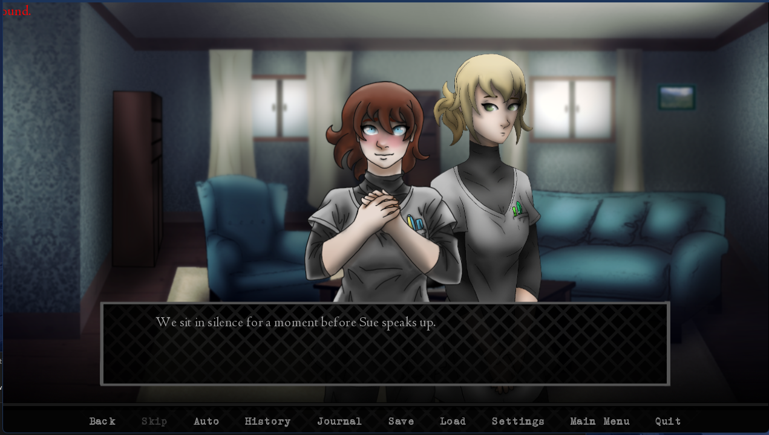

At some point it shows this “image not found” error but it’s too far off screen for me to tell what it is

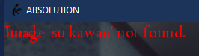 It’s underneath this error somehow.

Nothing else, onto the Dr. Young option

So far it’s the cleanest one yet

Inviting Dr. Young to help in the kitchen leaves Sue on screen, and that seems odd

Onto the full party, then the “no one invited” option. Starting break and it’s save 1 page 2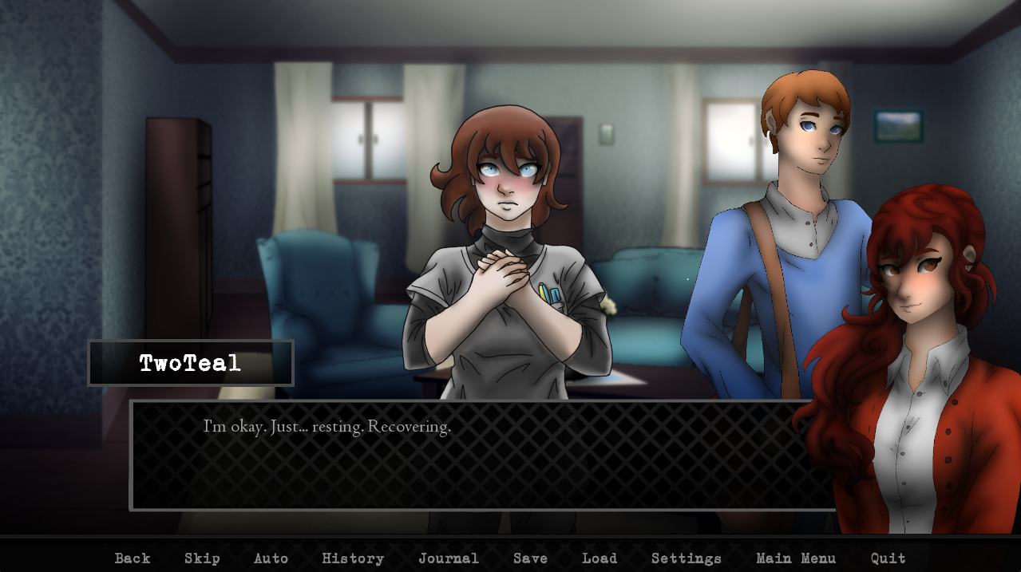

Julia’s sprite doesn’t show up again

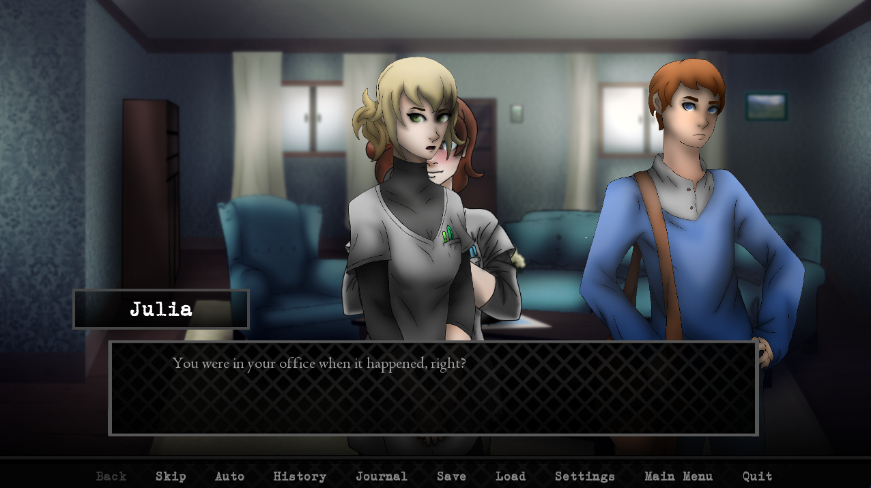

Except to cover Sue up (poor Sue)

Julia also isn’t an option to help with coffee

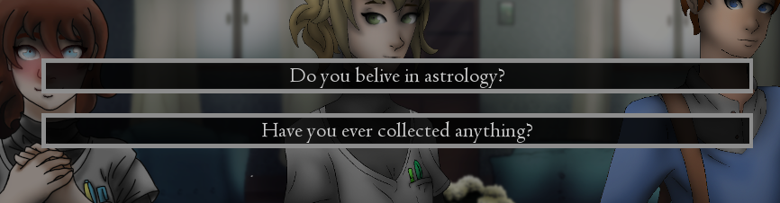

“Believe” instead of “belive”

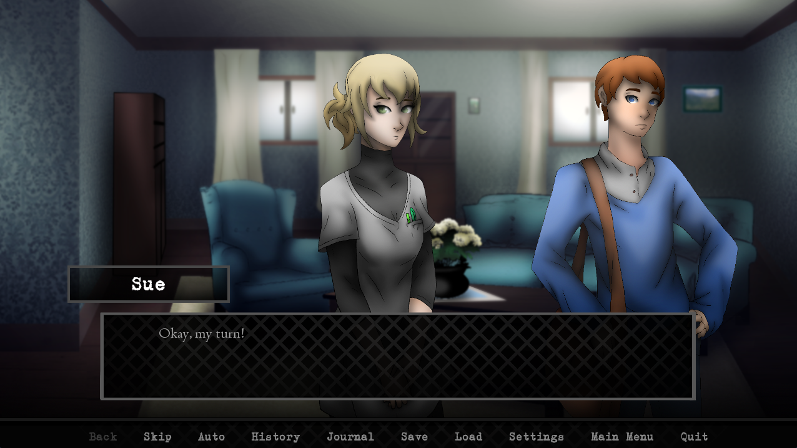

Sue disappears here for some reason

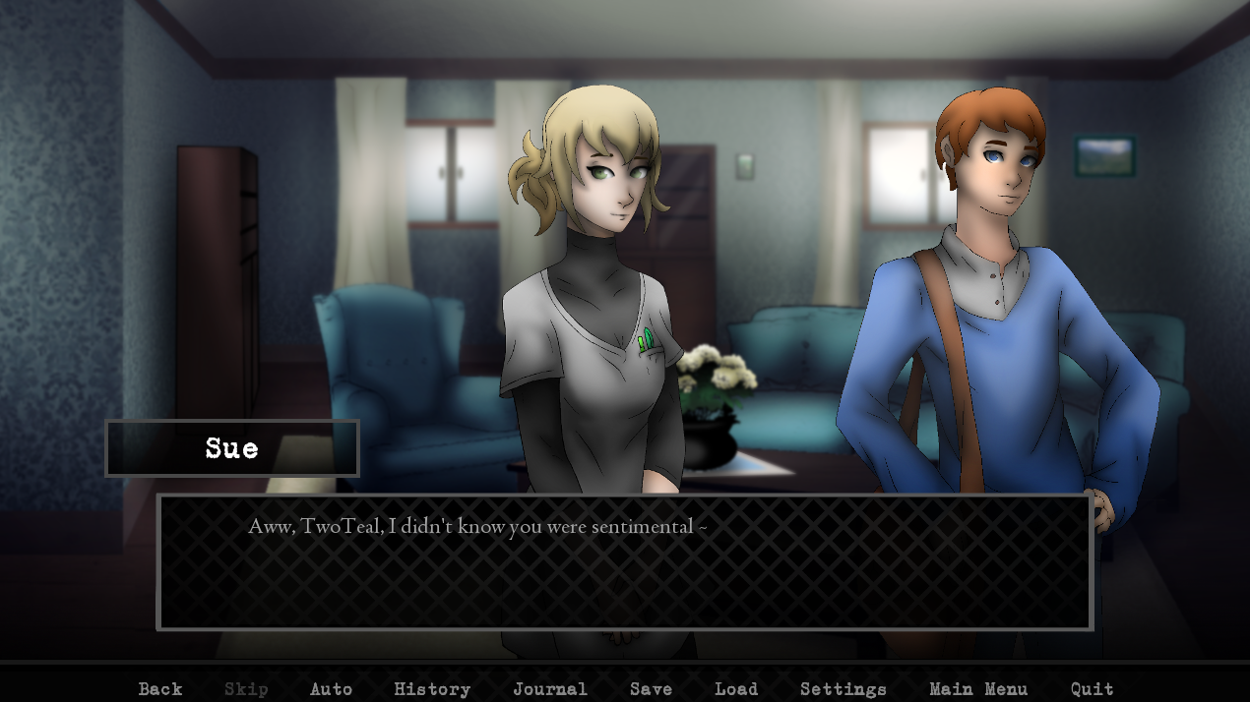

Also this one (I’m guessing it’s “sue kawaii” again)

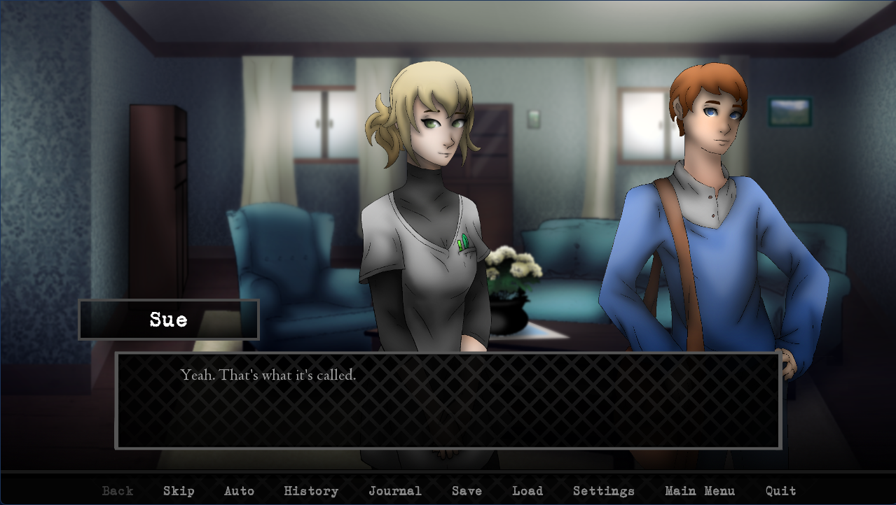

Again here (just covering my Sue bases)

Alright, the week officially starts after that event

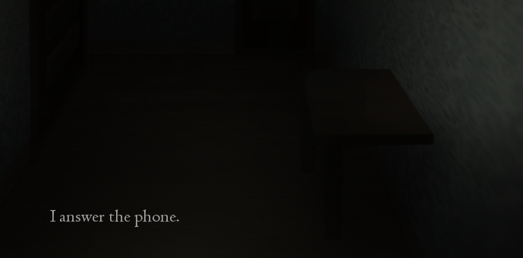

This looks a bit too obvious in the CG

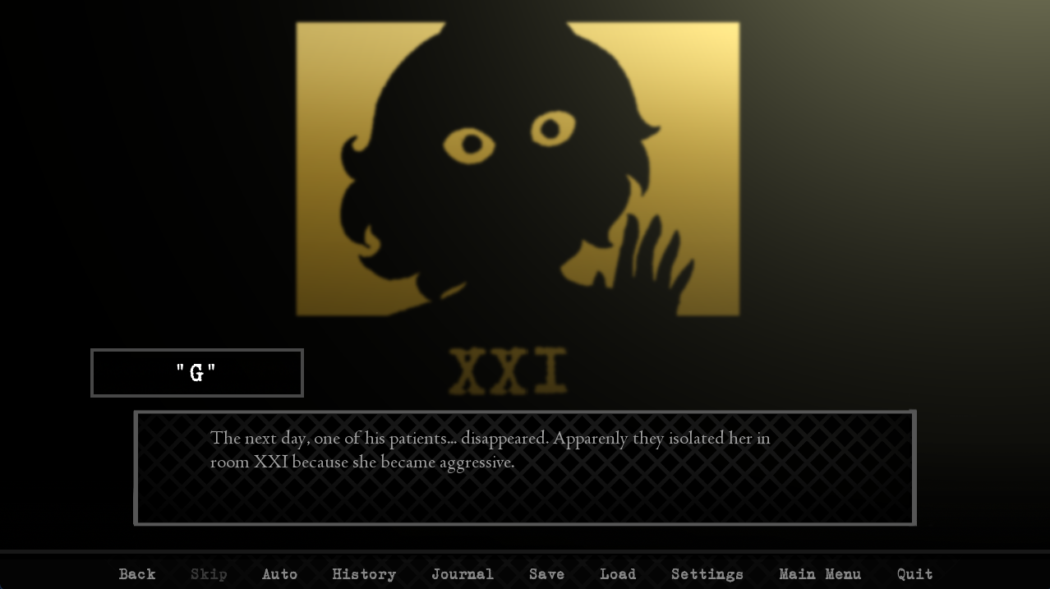

“Apparently” instead of “apparenly”

I think the “drugs” might have to be clarified as either a specific drug or illicit drugs, since I think the hospital has its own pharmacy, and just “drugs” by itself doesn’t have the same weight

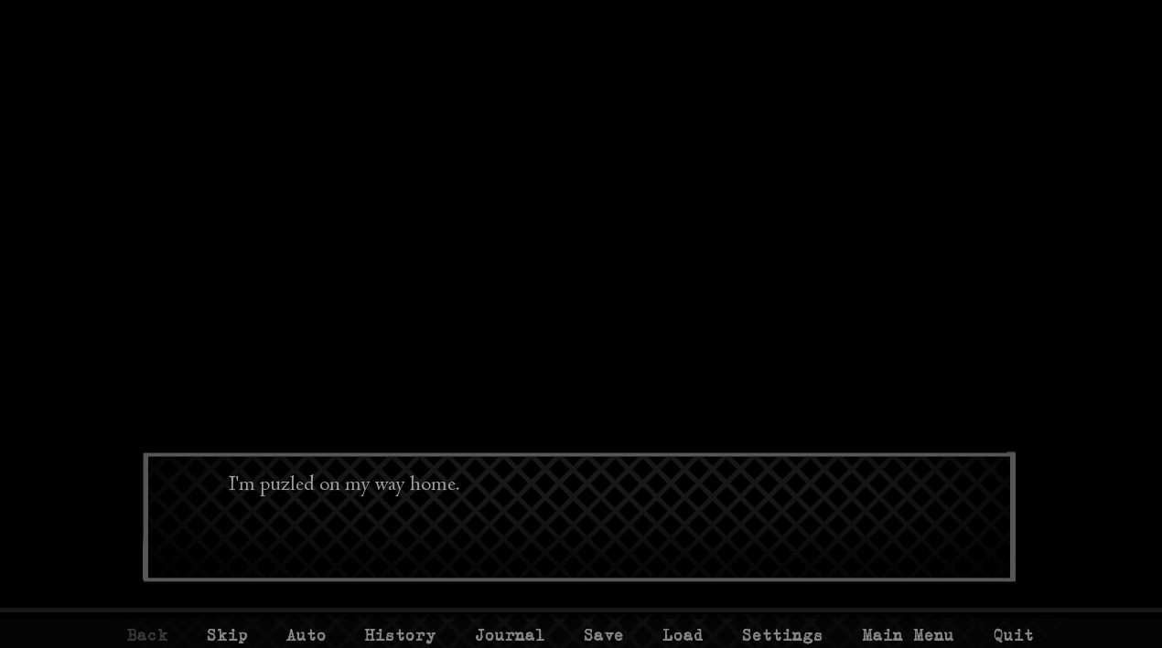

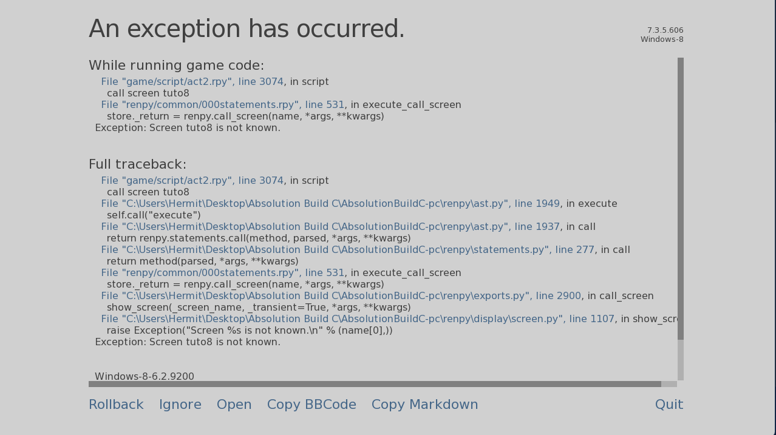

Soon after the “puzled” this exception happens

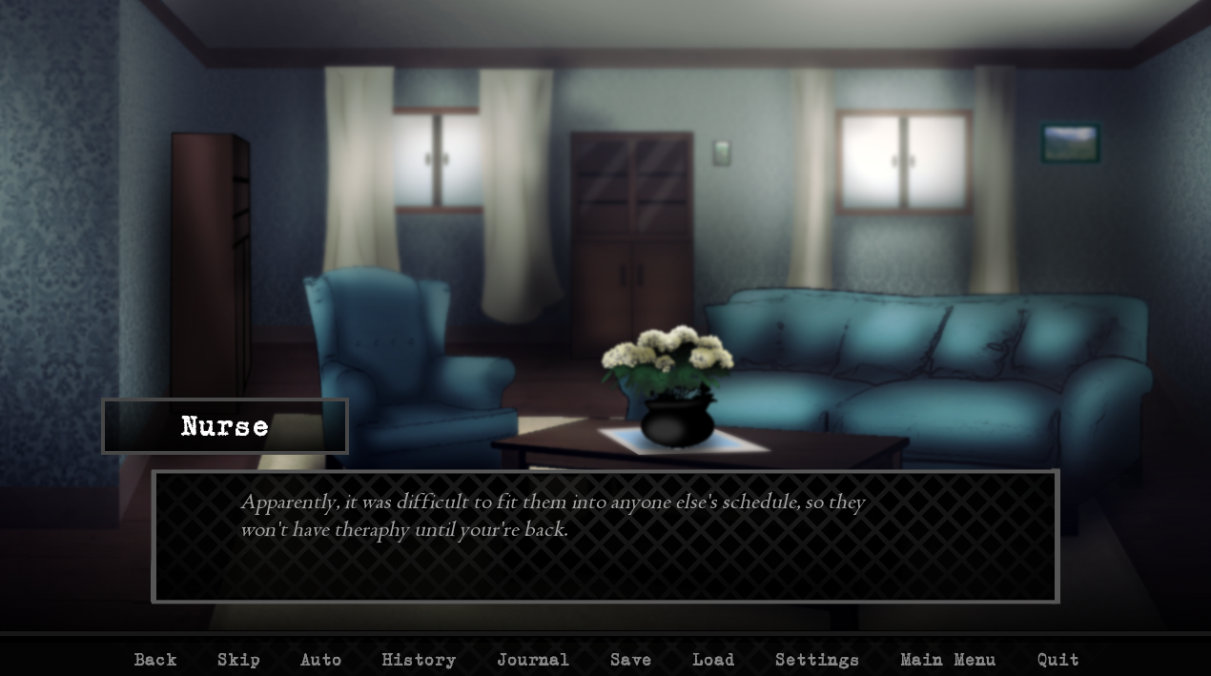

I checked back to the Sue event where you decline to invite anyone. “Theraphy” and “your’re”

Onto Wednesday, going back to work. So the build ends before Friday?